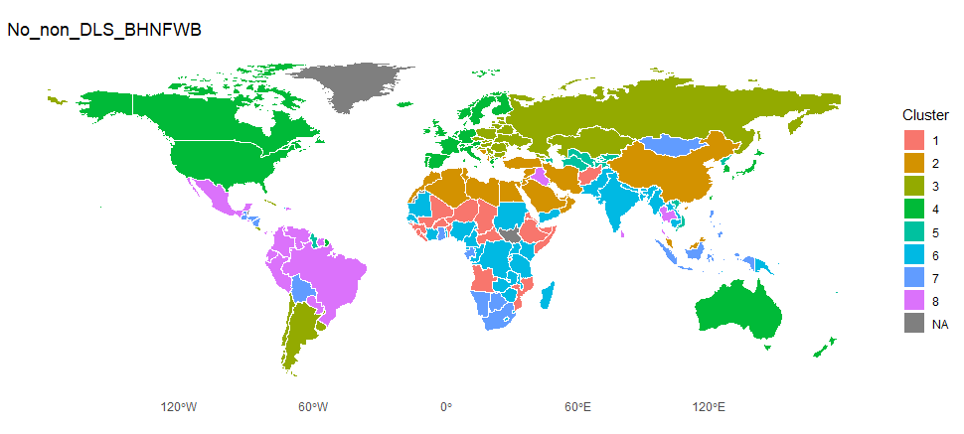
The clustering
The clustering includes indicators related to DLS dimensions from both SPI and extended variables. Opportunity indicators are excluded. A full overview can be found in ColonialAnalysis.xlsx sheet: No_non_DLS_BHNFWB. All possible DLS dimensions are covered, some with more indicators than others.
The colonial data update
Rebuilding the colonial data set from scratch allows us to expand the colonial data to 129 countries and their longest ruling colonizer. In combination with settler mortality 79 observations remain.
Fitting models
Full model including all colonized countries and clusters
  - Multinom(Cluster~colonizer)
  - p value: 8.563e-10 ***
  - The parameter estimates suggest overfitting, with very high estimates and small standard errors, so these parameters might not be useful
Aggregated model where all colonized countries are included but clusters 3,4,5 are combined into one cluster, since they don’t align that well with the colonial data.
  - Multinom(Cluster~colonizer+settmort)
  - P value 1.856e-11 ***
  - Reasonable estimates for parameters seems like a good model.
  - Below is a visualization of the predicted probabilities of belonging to a given cluster using Multinom(Cluster~colonizer+settmort)
